Flying Laboratory of Imaging Systems (FLIS) consists of an airborne carrier, suite of hyperspectral sensors and full waveform laser scanner. Data could be acquired for selected area of interest by full set of sensors simultaneously as well as by single sensor.
The airborne carrier is a Cessna 208B Grand Caravan with two hatches for RS instruments. The suite of airborne imaging spectroradiometers (hyperspectral system) consist of three sensors produced by the Canadian company ITRES Research Limited (CASI1500, SASI600, TASI600). Airborne laser scanner LMS-Q780 is developed by company Riegl. Basic technical specifications of the FLIS hyperspectral systems are shown in Table. Aircraft is equipped by additional systems which are necessary for top quality data acquisition and processing (e.g. gyrostabilized mount, navigation system)

FLIS is standardly equipped by following sensors:
 | 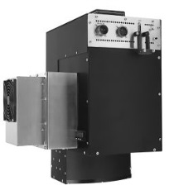 | 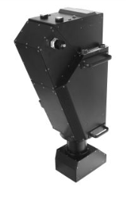 | 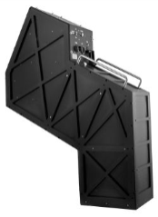
Sensor | CASI-1500 | SASI-600 | TASI-600
Region | VNIR | SWIR | LWIR
Spectral range [nm] | 380-1050 | 950 – 2450 | 8 000 – 11 500
Number of spatial pixels | 1500 | 600 | 600
Max. spectral resolution [nm] | 3.2 | 15 | 110
FOV [°] | 40 | 40 | 40

Number of hyperspectral, multispectral and laserscanner datasets were acquired by means of various systems (AISA Eagle, Leica ALS 50, UltraCam Eagle, Riegl LMS Q-680, HyPlant etc.) during activity of remote sensing department. Basic information about available datasets is at http://mapserver.czechglobe.cz/.

